STATE OF CALIFORNIA Edmund G. Brown Jr., Governor
PUBLIC UTILITIES COMMISSION
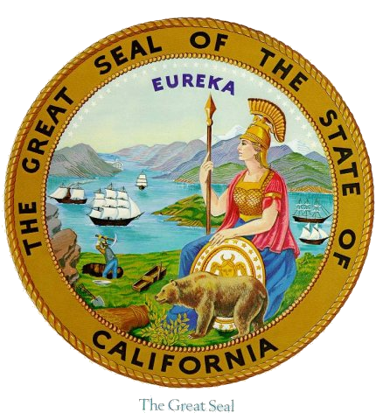
505 VAN NESS AVENUE
SAN FRANCISCO, CA 94102-3298

Workshop Agenda R.17-09-020

Working Group on Behind-the-Meter Resources and Weather
Sensitive Demand Response and Discussion of Comments on OIR

November 7, 2017 – Courtyard Room – 10:00 am – 4:00 pm

Call in info: Phone Number: 866-811-4174, Participant Passcode: 4390072#
WebEx: https://van.webex.com/van/j.php?MTID=me4afaabfe7b5a9c310661dff7339b8ec
Meeting number: 744 340 055, Meeting password: !Energy1

10:00 am – 10:10 am - Introductions and Announcements

10:10 am – 12:30 pm – Accounting for Behind-the-Meter Resources in the RA Construct
- Current Accounting Methods for Behind-the-Meter Resources (existing, incremental, and third-party contracts)
  - Energy Efficiency
  - Demand Response
    - Load modifying
    - Supply side
  - Distributed Generation

How should we account for the new generation procured through LCR RFOs (3rd party contractors)? These resources include: EE, DR, and DG.

- How should we account for BTM PV in ELCC and in the RA construct?
  - ELCC background and adopted methodology
  - Should we change the treatment of BTM PV in the calculation of ELCC?
  - If yes, should we also change the RA program to base the RA obligation on a consumption forecast vs. a sales forecast? Should the RA obligation be set relative to an LOLE study or continue to be based on peak load plus a static PRM?

12:30 pm – 1:30 pm – Lunch

1:30 pm – 3:00 pm – Weather Sensitive Demand Response
- Load Impact Protocols and weather sensitive DR
- Should weather sensitive DR be treated as a variable resource?
- Are the current QC values appropriate?

3:00 pm – 3:45 pm – Priorities for the RA Proceeding in 2018
- Summary and discussion of comments received on the R.17-09-020 OIR

3:45 pm - 4:00 pm – Wrap-Up/Next Steps

