STATE OF CALIFORNIA Edmund G. Brown Jr., Governor
PUBLIC UTILITIES COMMISSION
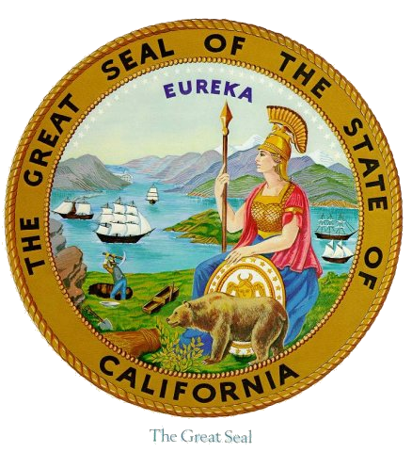
505 VAN NESS AVENUE
SAN FRANCISCO, CA 94102-3298

Workshop Agenda R.14-10-010
Workshop on RA Proposals for 2016
February 18, 2016 – Courtyard Room – 10:00 am – 4:30 pm
Call in info: Phone Number: 866 811 4714, Participant Passcode: 4390072#

10:00 am – 10:15 am - Introductions and Announcements (Donald Brooks, Energy Division)
  - Today’s Objective: Participants better understand proposals, provide input, and submit post-workshop comments; proposal authors can consider whether improvements are appropriate.

10:15 am – 11:30 am - Establishment of RA Obligations and ELCC (Donald Brooks, Energy Division)
  - Revised inputs and modeling methods since draft results
  - Establishment of RA obligations, average solar and wind ELCC
  - Monthly values and phase in schedule
  - Responses to party comments and questions
  - Next Steps/Questions - Technological and locational granularity

11:30 am – 12:15 pm – Development of Coincidence Adjustments (Dr. Miguel Cerrutti, CEC)
        - Background on current CEC practices
        - Comparison to practices of other states or balancing authorities
  - Questions/Answers

12:15 pm – 1:15 pm – Lunch

1:15 pm – 2:30 pm – Demand Response Dispatch and Notification
        - Staff Proposal to retain current requirements through 2017 for DR to qualify for Local RA
(Meredith Younghein, Energy Division)
        - CAISO’s Local Capacity Requirements technical study process (Dr. Karl Meeusen, CAISO)
        - Maintaining current requirements (Mona Tierney-Lloyd, Joint DR Parties)
        - Impact of 20 minute dispatch rule change on 30 minute BIP and potential solutions (Martin Blagaich, SCE)
        - Questions/Answers

2:30 pm – 3:15 pm – Suspending load impact protocols for third-party integrated DR
        - Staff Proposal, Rachel McMahon, Energy Division
        - Party Proposal, Mona Tierney-Lloyd, Joint DR Parties
        - Questions/Answers

3:15 pm - 3:30 pm – Stretch Break/Coffee Break

3:30 pm – 4:15 pm - Other Party Proposals
  - PG&E proposals (Jenny Kim, PG&E)
    - Expanded pre-dispatch classification
    - Allocation of flexible RA obligations
  - Questions/Answers

4:15 pm – 4:30 pm - Next Steps/Follow-up Items

Thank you for your participation
WebEx information:

Workshop on RA proposals for 2016
Thursday, February 18, 2016
10:00 am | Pacific Standard Time (San Francisco, GMT-08:00) | 6 hrs 30 mins

Join WebEx meeting

Meeting number: | 745 135 759
Meeting password: | !Energy1

Join by phone
Call-in: (866) 811-4174
Participant: 4390072

